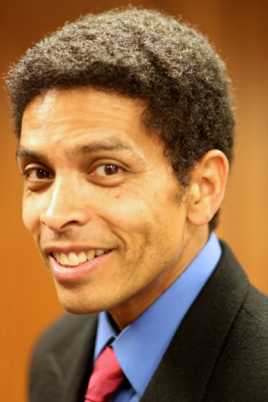
_{Albert Smith}

phone (805) 758-0548
Hair : Black albertsmith.al@gmail.com
Eyes : Brown www.thealbertsmith.com

FILM:
Mixteco Boy Supporting Animo Film & Theatre
The Prophecy Lead Eddie Cachu /NewMediaTV1
The All Nighter Supporting Richard Jimenez

TV/New Media
Los Anormales Co-Star NewMediaTV1
The Conductor !! Lead Albert Smith/OCTV Project
Yayo’s World Co-Star OCTV Show/Silvia Diaz-J. Huerta

THEATRE;
Burundanga Gorka Armando Rey/Teatro De Las Americas
Los Encantos Del Relajo San Judas R. Sanchez/ Teatro De Las Americas
Tus Amigos Nunca Te Mario R.Sanchez/ Teatro De Las Americas
Harian Dano
Latinologues Janitor Carlos Rick Najera/Rafael Agustin

COMMERCIALS:
Pete’s Green Supporting Nomad Agency
Recycle Used Oil Co-Star City of Oxnard California/J.Alcala

EDUCATION/TRAINING:
Oxnard College Film & Television Production Andres Orozco/Kitty Merrill
Berg Studios Scene Study Gregory Berger-Sobeck
Teatro de las Americas El Actor En Movimiento Tony Duran
James Donlon Studio Physical Theatre & Movement James Donlon

SPECIAL SKILLS:
Mime , English-Spanish Speaking , Facial Expressions , Hand Puppets , Regional Latino Accents, Film Video Production, Grip , General Cycling

